2017 Fall: COMP-SCI 5590/490 - Special Topics Mobile Programming

Lesson 3

**Lesson Overview**

This lesson helps in understanding some important aspects of android such as fetching JSON data from APIs, parsing the JSON data, handling errors, using the Async Task Class and some Java elements along with usage of List View.

**In-class Programming – Quake Info App**

Create a mobile application with the following requirements.

1. The main activity should be a list of earthquakes with information as shown below.

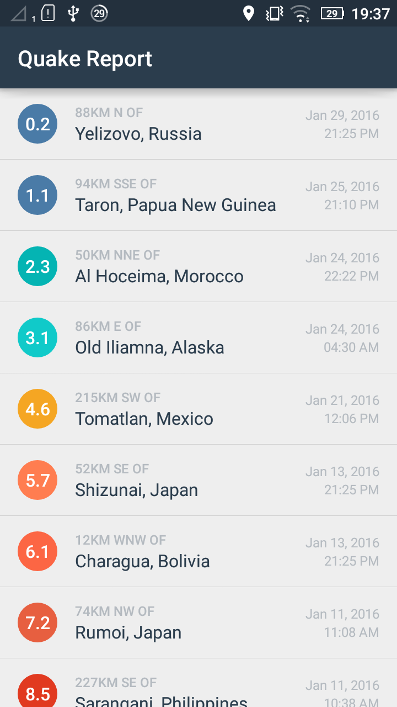

1. On clicking any item Earthquake, the user is to be directed to the webpage of USGS which contains further information about the earthquake in any web browser.

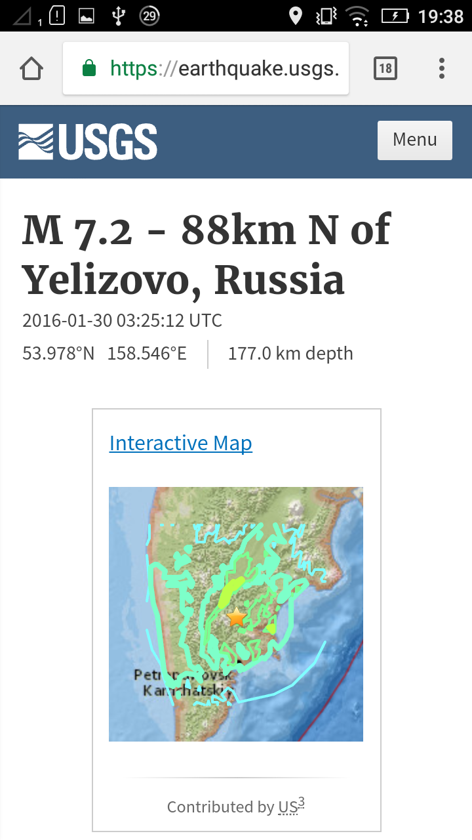

1. Follow the three TODO instructions in the QueryUtils.java file and two more TODO instruction in the EarthquakeActivity.java file and AndroidManifest.xml to complete the functionality